Technical details

Spring Boot

Maven

H2

<http://localhost:8080/createData> 🡪 this will calculate the reward points and create dataset information in H2 DB.

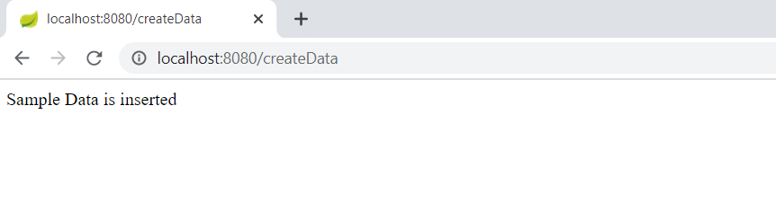

<http://localhost:8080/getRewardPoints?customerName=customer1> 🡪 Get the customer total earning points and monthly wise total earning points

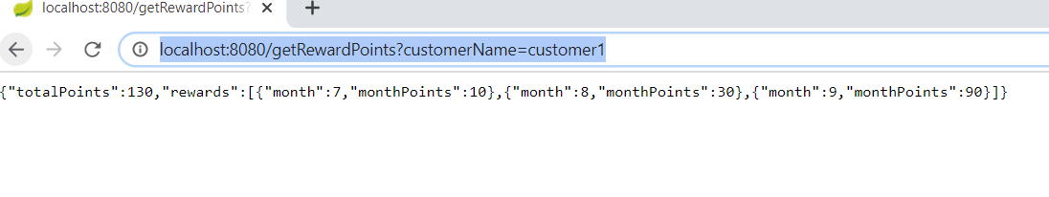

[http://localhost:8080/getRewardPoints?customerName=customer](http://localhost:8080/getRewardPoints?customerName=customer1)2 🡪 Get the customer total earning points and monthly wise total earning points

